General Instructions for Completing DOTDTAP Application

- These general instructions and the application checklist should help make completing the application easier. If, after reading through these materials, you have any questions, contact:

Louisiana Department of Transportation & Development
1201 Capital Access Road
P.O. Box 94245
Baton Rouge, LA 70804-9245

Attention: Mr. Brian Nunes
Phone Number: (225) 379-1585
E-mail: Brian.Nunes@la.gov

- The first step is to read the DOTD Transportation Alternatives Application Guide. This guide describes the kinds of projects that are eligible and helps you determine whether your project is eligible and how it should be classified.

- You should determine if you are in a Metropolitan Area (MPO) by referring to the map following this section. If you are in a Metropolitan Area, please contact your MPO representative. A listing of MPO directors is in the Application Guide.

- In preparing the documentation, remember that the applications will be copied and distributed to various people who require information for grading and/or selection of projects. With this in mind, here are some tips for preparing your application.

  - You must use the application form to submit your project. Remember that well completed applications are key to project selection and funding. Applications should be complete and accurate.

  - Wherever possible, use only the space available in the application form to provide the requested information.

  - Provide enough detail in your project description that reviewers, graders and selectors can clearly understand your project.

  - If you attach information, provide it in a format that can be easily copied on 8 ½” x 11” paper. Also, if the application is to be bound, send applications either stapled or in a 3-ring binder type format. NO SPIRAL BINDING OR DUOTANG FOLDERS PLEASE.

  - Supplemental information that gives a clearer picture of the impact of the project may be included. However, please limit additional information to phases of the project that is relevant to the spending of the DOTDTAP Funds sought.

- Some additional points that are important enough to be emphasized:

- The sponsor must be a public agency, and the application must include a certification signature of someone with authority to commit that public agency to a contract.

- Funds spent prior to authorization are not eligible for reimbursement and cannot be counted toward matching funds. Consultant services or sponsor provided planning and/or design services for the project are not subject to this timing limitation as they are funded by the Sponsor.

- Project cost estimates must contain enough detail that the various cost elements of the project are clear. Detailed estimates in the body must be consistent with the final page of the application.

- If work is proposed on or adjacent to a facility currently open to use by the public, an estimate of the amount needed to provide Traffic Control (signs, barriers, cones, temporary markings, etc.) during construction should be provided.

- This is not a grant program! The DOTD Transportation Alternatives Program is a COST-REIMBURSABLE program. Costs incurred before FHWA project authorization (expenditure approval) are not compensable. All contractual documents must be executed before items can be reimbursed.

- Please note, that unlike the Transportation Enhancement Program where other Federal funding sources may be used as part of the Sponsor’s match, DOTDTAP does not allow this. THE ONLY EXCEPTION is the use of National Recreational Trail funds which can be used as matching funds on DOTDTAP projects. Though other Federal funding sources can be used on the project, they can only be used to cover non-participating items. The Sponsor will be responsible for coordination of any other Federal funds that they use.

- The Sponsor should submit 6 stapled copies and an electronic copy of their application. The electronic copy should be a color pdf containing all submitted material and must be submitted along with the hard copy applications (separate email is not allowed).

DETAILED INSTRUCTIONS FOR COMPLETING THE APPLICATION

Sponsor Information: Please provide all requested information. Sponsor must be a governmental agency, such as local, state universities (not private), regional, parish, state or federal agencies. In general, the sponsor will be responsible for supplying the match share, managing and maintaining the project and will be responsible for the legal liability for the project. Please provide Sponsor’s federal identification and UEI numbers. Please provide Sponsor’s DOA Vendor number if available.

Consultant Information (If applicable): Only fill out if known. Please provide all requested information. Please note that consultant firm on LaDOTD’s disqualified or disbarred lists may not be used on any LPA Project with LaDOTD.

Brief Project/General Information: Please provide all requested information, including State Legislature District Numbers in which the project is located. Later in the application there is space provided for a detailed project description. Keep in mind that in this space the project description should be as brief as possible. The project location should read as running from west to east or north to south and should include road names and numbers. Please include a map, with a north arrow and scale, showing the project location, termini points, length, typical section (if available). Locate on the map any public facilities (parks, schools, etc) that may be affected by the proposed project. Indicate on the map if any state right-of-way is used for the project. If there are other projects being submitted at the same time, please indicate what priority should be put on the project in relation to the other submitted projects. Please provide any information on other phases that are under design or construction.

Detailed Project Description: Describe all necessary work needed to complete the proposed project and overall cost of all phases. Description should reflect only activities checked under the project category or categories in the application. This description should fully describe all aspects of the work that the Sponsor is requesting funds for. Phased projects should have no more than 3 phases. Phases must be logical and should be “stand-alone” projects. Sponsor should indicate which phase is being applied for.

Maps, Plans, and Photographs: Attach project location and vicinity map(s), project boundary map and site plan (if available). Include photographs of the existing site and/or facility. Maps should be constructed in a “reproducible friendly” format. Maps should have a north arrow with scale and read as running from west to east or north to south (“north-up orientation”) and should include road names and numbers. State and Federal routes involved in the proposed project should be marked. Right-of-way to be used on the project should be indicated along with whether State owned property is being used. Phased projects should show all phases with project limits for each phase. Project phase for which funding is being requested should be clearly indicated with specific information on that project alone being detailed.

Project Benefits: Please detail how the project benefits the state and/or community. Benefits could possibly include economic, quality of life, quality of transportation, and quality of environment. If the project benefits safety of pedestrians and/or bicyclists, please include information on applicable accident/fatality information and records. If project provides access to public facilities, please detail what facilities are affected and the portion of the population that will benefit from the project. If applicable, express how the project will address high-priority areas and equity.

Implementation: Please indicate if this project is ready for project funding, i.e. has any of the implementation strategy been completed—design, environmental documentation, right-of-way, etc. Also, please describe the implementation strategy, including start date, design date, implementation timeframe, anticipated completion date, and any foreseen “hold-ups” for the project. In addition, indicate what steps will be required to fully implement the project.
For construction projects only, implementation schedule should be projected to the delivery of final plans, cost estimate and bid documentation to LA DOTD. Once the final plans are delivered, LaDOTD will schedule the project according to availability of funds.
Please note that it is a program policy, that if a project has not shown significant progress (as determined by the DOTDTAP Manager) 3 years after inclusion in the program, the project may be cancelled.

Project Cost: Itemize all project elements and costs. Please note that all construction projects will be bid and advertised through LADOTD. If phased, only that phase for which funding is being requested should be detailed, however, the projected overall cost for all phases should also be indicated. Include calculations to support the budget, as budget considerations are very important. List item, description, quantity, unit price, amount, labor costs, supplies and materials, etc. Include items for mobilization, temporary signs and barricades, and construction layout (if applicable and layout is to be performed by contractor). For projects involving historic buildings, it is strongly suggested that the Sponsor contact professionals who deal with historic renovation as “hidden costs” may occur, such as asbestos and lead paint abatement or extra costs to maintain historical accuracy. Additional Federal funding will not be available to cover inadequate cost estimates and may jeopardize the completion of the project. Indicate if Sponsor is providing additional funds above the required local match and the amount of additional funds. (Do not include engineering costs as additional funds as this is a requirement of the program that Sponsor pays all design engineering, construction engineering and inspection costs.) Indicate if right-of-way acquisition is to be used as the required local match with a projected value of the property. Once the project is selected, and upon Federal Highway Administration approval, the property value must be established in accordance with Federal guidelines and approved by the DOTD Real Estate Section. All right-of-way acquisitions must be cleared through the DOTD Real Estate Section.

Operation and Maintenance Costs: As LaDOTD does not assume the maintenance required for DOTDTAP projects, the Sponsor must show a plan for operation and maintenance of the project. Projects should be in place and maintained for a period of not less than ten (10) years, unless otherwise agreed upon. To ensure the appropriate upkeep of this investment, applicants must submit maintenance plans (including budgets) and agreements for the projects listed on the application. Include an estimate of the annual cost of operation as well as the annual cost of maintenance and the source of those funds. For projects with landscaping or for vegetation management, a formal Operation and Maintenance manual will be required at final submittal; this document will be subject to review by appropriate DOTD personnel to ensure its adequacy.

Maintenance on landscaping projects within state owned right-of-way should be discussed with the appropriate LA DOTD District Operations Engineer.

Federal Cost Share Requested, Local Funding and Source: Please fill out all requested information. The Sponsor may be required to provide for design and construction engineering services in accordance with LaDOTD standards at their own expense. List sources and amounts of your match funds. (Please note that design engineering and construction inspection costs are NOT match funds or additional money.) The only other federal funds that may be used as a source of match on DOTDTAP projects are National Recreation Trail funds. Funds for the project may be supplied from other federal agencies; however, they should be shown as non-participating to the DOTDTAP program. Any additional coordination needed to secure federal funds from an agency other than FHWA will be the responsibility of the Sponsor. Line 3 should show only those funds being requested from the DOTDTAP program rounded to the nearest $100.

Certification: Certification should be from an individual with the authority to sign on behalf of the Sponsor. By signing the certification, the signatory is certifying that the Sponsor has the legal authority to enter into contract to implement the project and that all information provided is complete and accurate to their best knowledge.
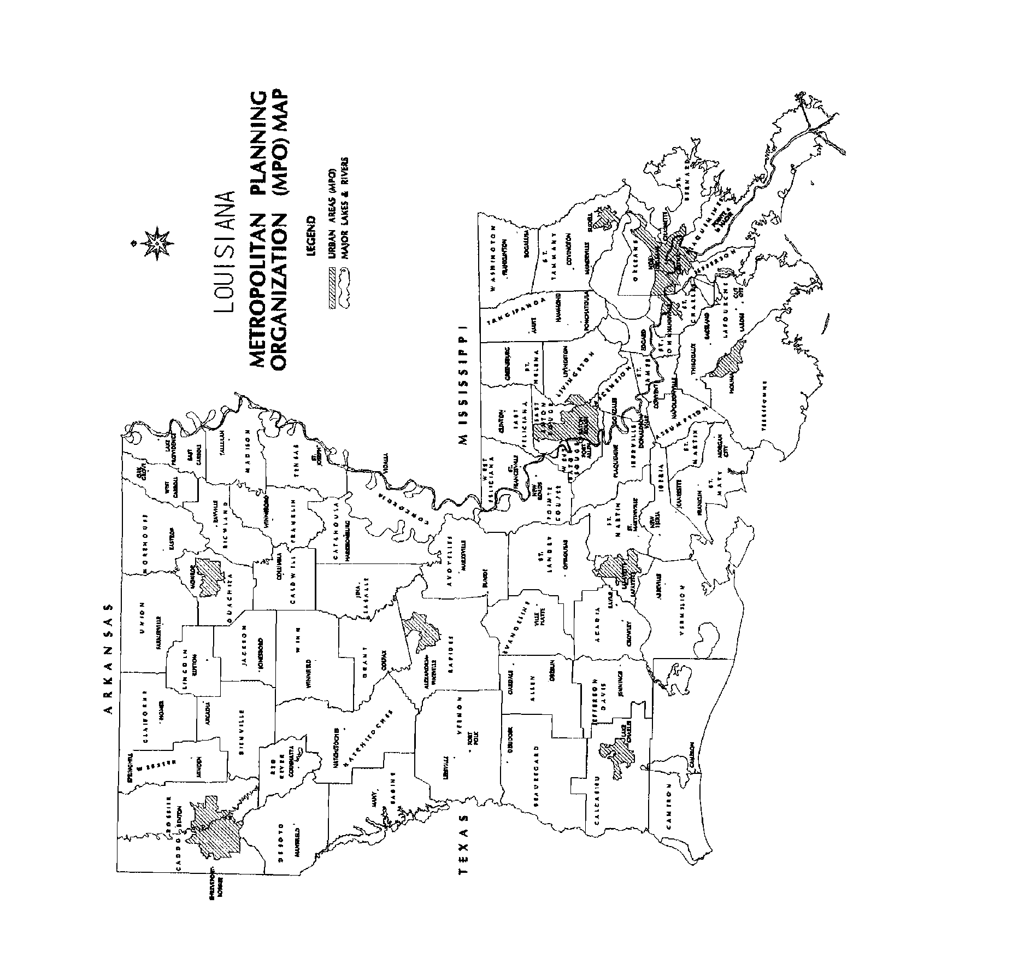
APPLICATION CHECK LIST

Not every item in the list that follows will apply to all applicants. It can be helpful as a guide, however, in seeing to it that all parts of the application process have been completed.

- Review eligibility requirements for the type of applicant.

- Review the DOTDTAP Information Guide to insure eligibility of the project and its category.

- Verify that historic projects are listed on or eligible for the National Register.

- Verify project’s conformance to disability regulations.

- Verify that the possibility of asbestos abatement and lead paint containment has been taken into account.

- Provide location maps, project boundary maps, site plan, and photographs of existing site or facility.

- Prepare itemized list of all project elements and their costs, including quantity, unit prices, and so on.

- Identify ownership of all property and, if property is to be acquired, the value of the property. For right-of-way property costs to be eligible for funding through the DOTDTAP Program, the property cannot be owned by the Sponsor BEFORE SELECTION into the Program.

- For projects on LA DOTD Rights-of-way, contact appropriate District office in your area for approvals/permits.

- List the local support for the project.

- Provide description of plans for maintenance and management of the project including sources of funding.

- Provide list of sources for matching funds and amounts. Note that the Sponsor’s match share, if supplied by Federal funding sources must originate from the National Recreational Trails Program.

- Provide certification with a signature of an individual authorized to commit the applying body to a contract.

- Prepare required number of copies of the original application and accompanying supplements.

- Send original and copies to the LA DOTD at the address shown on the application.

